**PROJECT REPORT**

### Project Title: Social Media Campaign-Create a mock Social Media Campaign use Ideal Block Facebook

### Project Link:<https://drive.google.com/file/d/1wwaASe-Q03eZMXsZXCB627QP1IC2fRNf/view?usp=drivesdk>

### Team Members:

1. S.Madhavan (6FBEE6624434324B6DE43CCFD71331F7)

2.M.Hariprakashan (44D80E74B593523A403456F0A459D279)

3.N.Kutbudeen shait (0DD550166231FCEA2784DAFC16B0483A)

4.V.Karuppuraja (3655E5037CFA241A65E4109AA6E362DE)

### Table of content

|  |
| --- |
| 1.Introduction1.1Overview1.2 Purpose2.Problem Definition & Design Thinking:2.1 Empathy Map2.2 Ideation & Brainstorming Map3.Result4.Advantages and Disadvantages5.Applications6.Conclusion |

### 1.INTRODUCTION:

Creating a project report for a social media campaign on Facebook is a structured way to document and communicate the goals, strategies, execution, and outcomes of your campaign.

### 1.1 Overview:

State the primary objective of your campaign. This could be to increase brand awareness, drive website traffic, boost sales, or achieve another specific goal.

Audience:

Describe your target audience, including demographics, interests, and behaviors.

Key Message:

Summarize the core message or value proposition that you want to convey through the campaign.

Campaign Elements:

List the main components of your campaign, such as content types (videos, images, articles), advertising methods, and any interactive elements (polls, contests, etc.).

1.2 Purpose

Increase Brand Awareness:

To introduce your brand to a wider audience, especially if you're a new business or launching a new product or service.

Drive Website Traffic:

To encourage Facebook users to visit your website, explore your content, and potentially make a purchase or take another desired action.

Boost Sales and Conversions:

To promote products or services, drive sales, and increase revenue through Facebook advertising and promotions.

Engage and Build a Community:

To foster a sense of community among your followers, encouraging discussions, user-generated content, and social interactions.

### 2.PROBLEM DEFINITION & DESIGN THINKING:

### Problem Statement:

**Issue/Problem]**: Describe the social issue or problem that your campaign aims to address. Be specific about the problem and its impact.

**[Affected Audience]**: Identify the audience or community that is directly affected by this problem.

### 2.1 Empathy Map

### 

### 2.2 Ideation & Brainstorming Map

### 

### 3.RESULT

### Steps for creating Social Media Campaign:

1. Set Clear Goals and Objectives:

Identify what you want to achieve with your Facebook campaign. Is it increased brand awareness, lead generation, sales, or community engagement? Ensure your goals are specific, measurable, and aligned with your overall marketing strategy.

2. Define Your Target Audience:

Create detailed buyer personas or audience segments based on demographics, interests, and behaviors. Understanding your audience is crucial for effective targeting.

3. Choose Your Campaign Type:

Decide on the type of campaign you want to run. Facebook offers various campaign objectives, including brand awareness, reach, engagement, traffic, conversions, and more. Choose the one that aligns with your goals.

4. Create Engaging Content:

Develop content that resonates with your audience and your campaign objective. Content may include images, videos, blog posts, infographics, and other multimedia. Ensure it's visually appealing and aligned with your brand's message.

5. Develop a Content Calendar:

Plan your content schedule, including posting frequency and timing. Consistency is key in social media, so a content calendar helps you stay organized and ensure a steady flow of content.

6. Advertise or Boost Posts (if applicable):

If your campaign requires paid advertising, set up Facebook Ads, target your chosen audience, and define your budget. You can also boost individual posts to increase their visibility.

7. Engage with Your Audience:

Actively respond to comments, messages, and interactions from your followers. Engaging with your audience helps build relationships and trust.

8. Monitor and Analyze:

Regularly track the performance of your campaign using Facebook Insights or other analytics tools. Analyze metrics like reach, engagement, click-through rates, and conversion rates to assess the campaign's effectiveness.

9. Optimize Your Campaign:

Based on your analysis, make data-driven adjustments to your campaign. This might involve tweaking content, audience targeting, ad spend, or posting times to improve results.

10. Measure ROI:

Assess the return on investment by comparing the campaign's cost to the value it generated (e.g., sales, leads, brand visibility). This helps determine if the campaign was successful.

11. Report and Communicate:

Create a report summarizing the campaign's performance, key metrics, and insights. Share this information with stakeholders and team members.

12. Scale and Iterate:

If the campaign was successful, consider scaling it or using the insights gained for future campaigns. Continue to iterate and improve your Facebook marketing strategy.

13. Test and Experiment:

Don't be afraid to experiment with different content types, ad formats, and targeting strategies. A/B testing can help you discover what works best for your audience.

14. Stay Compliant:

Ensure that your campaign complies with Facebook's advertising policies and community standards. Failure to do so can result in ad rejection or account suspension.

Top of Form

Result Screenshot:

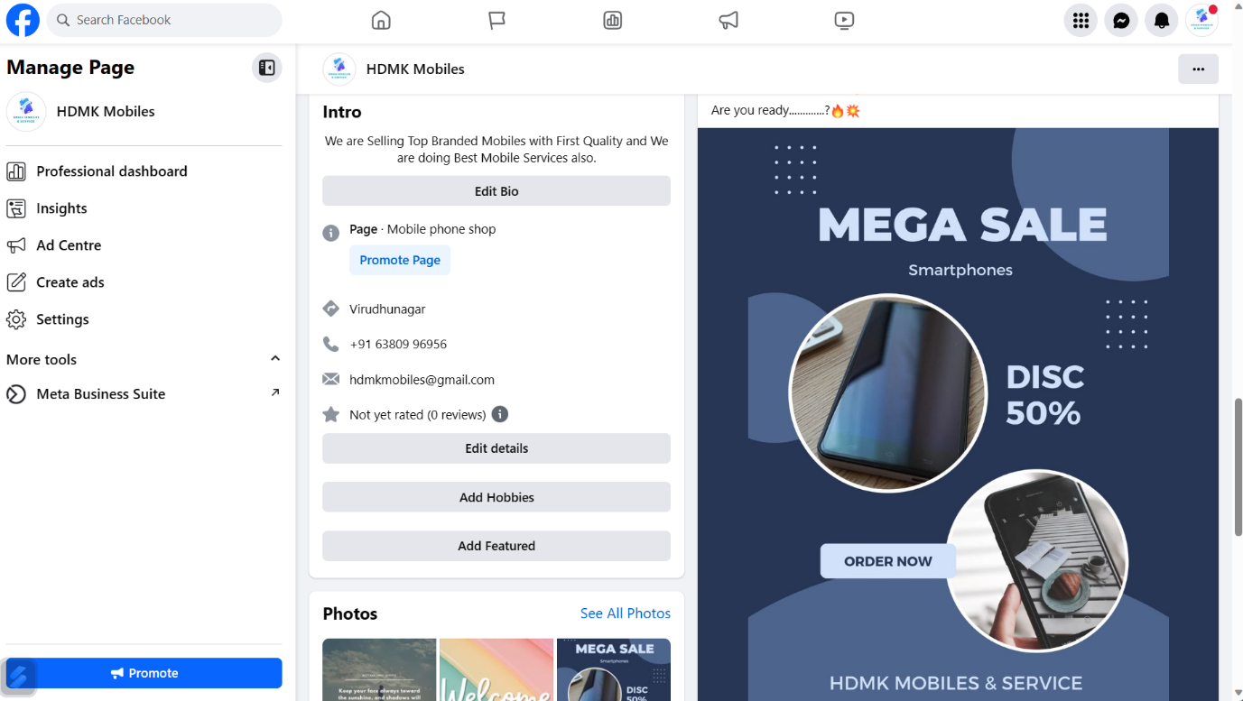

### 4.ADVANTAGES AND DISADVANTAGES

### 4.1Advantages:

**Vast User Base:** Facebook is one of the largest social media platforms with billions of active users. This provides a wide and diverse audience to reach.

**Targeted Advertising:** Facebook's ad platform allows you to target specific demographics, interests, behaviors, and locations. This precise targeting can lead to higher conversion rates and cost-effective advertising.

**Engagement Opportunities:** Facebook provides various engagement tools, including likes, comments, shares, and private messaging, allowing for direct interaction with your audience.

**Visual Content:** You can easily share multimedia content such as images, videos, and live streams, which tend to be more engaging and shareable than text-only content.

### Disadvantages:

**1.Algorithm Changes:** Facebook frequently updates its algorithm, which can affect the organic reach of your posts. These changes can make it more difficult for your content to appear in users' news feeds.

**2.Ad Costs:** While Facebook advertising can be cost-effective, competition for ad

placements can drive up costs, making it challenging for smaller businesses with limited budgets to compete.

**3.Ad Fatigue:** Overexposure to the same ads can lead to ad fatigue among users, causing them to ignore or actively hide your content.

**4.Privacy Concerns:** Facebook's handling of user data and privacy concerns have resulted in increased scrutiny and changes in advertising policies. This can impact your targeting and tracking options.

5.APPLICATIONS:

1. Define Your Goals:

Determine the specific objectives of your campaign. Are you looking to increase brand awareness, drive website traffic, generate leads, boost sales, or achieve another goal?

2. Understand Your Target Audience:

Develop detailed buyer personas to understand your audience's demographics, interests, and behaviors. Knowing your audience is crucial for effective targeting.

3. Choose the Right Campaign Type:

Select the appropriate campaign objective on Facebook. This could include brand awareness, reach, engagement, website traffic, conversions, or another objective that aligns with your goals.

4. Create Engaging Content:

Develop content that resonates with your audience and aligns with your campaign objective. This content may include text, images, videos, articles, or multimedia content.

5. Develop a Content Calendar:

Plan your content schedule, including the frequency and timing of your posts. Consistency is important in social media, so a content calendar helps you stay organized.

### 6.Conclusion:

A well-planned and executed Facebook social media campaign can significantly contribute to your organization's success by helping you connect with your audience, achieve your marketing objectives, and adapt to the ever-evolving landscape of social media marketing.